State of Illinois
Department of Transportation
Bureau of Business Services
Specifications & Questionnaire for a Stationary, Rotary Screw-Type, Air Compressor
November 2019
This specification and questionnaire covers a stationary, electrical powered, rotary screw style air compressor to provide air service to our repair shop used by the Department of Transportation Division of Highways Operations forces. In an effort to improve parts and service availability and increase tool life, the Department of Transportation is specifying units and accessories as outlined below.
Each bidder shall submit with his bid two sets of descriptive literature and specifications describing all the equipment and options proposed. This information shall be clearly marked to indicate the make, model, and accessories proposed to be furnished. If this information is not furnished, the bid may not be considered.
Bidders quoting on specified equipment must submit with their bid written proof of the following:
- The manufacturer of the equipment proposed has been actively involved in the manufacture of the equipment called for in the Proposal for a period of not less than 5 years.

- Parts and service for the equipment proposed are readily available within the State of Illinois.
Unless otherwise specified, the proposed equipment shall be complete in all parts and ready for immediate use upon delivery.
Bidders are advised to carefully read these specifications as changes have been made since the last solicitation issue.
Proposed with this Bid:
Make:
Model:
Manufactured By:
Bidder:
Telephone:
Contact Name:
Email:

The Illinois Department of Transportation reserves the right to waive minor informalities, deficiencies or technical variances which by their nature are restrictive to a given manufacturer, if in its’ judgement, it would be in the best interest of the State to do so and it would not prejudice the rights of other bidders.
Serviceability will be a factor in award. Successful bidder shall either be able to provide service after purchase or shall indicate other qualified service facilities able to service equipment, within a reasonable period of time at agency locations. Bidder shall provide documentation and enumerating service locations. A Review of the bidder's ability to provide prompt parts and service to the State of Illinois and in particular to the delivery location, will be considered in determining award.
Bids will only be accepted from established manufacturers or their authorized dealers. Any dealer submitting a bid hereby guarantees that it is an authorized dealer of the manufacturer and that the manufacturer has agreed to supply the dealer with all quantities of products required by the dealer in fulfillment of its obligations under any resultant contract with the State. Bidder must submit authorized dealer letter upon request.
Warranty:
Manufacturers’ standard warranty shall be provided. Bidder shall attach copies of warranty with bid. Warranty shall commence at the Illinois Department of Transportation in-service date. If any equipment fails to conform to the warranties during the applicable warranty period, the Vendor or Manufacturer will adjust, repair or replace the equipment at no charge to the Department as soon as possible upon notice from the Department. Equipment shall be repaired on-site and will be performed at no additional cost to the Department.
The Vendor may provide or perform warranty service at a dealer location within the Districts geographic region if on-site repair is not possible. Vendor shall facilitate pickup and delivery of equipment at Vendor's cost if warranty repair(s) are made off-site during the warranty period. The contract Vendor is responsible for any failure of their allied or sub-contractors fulfillment of said warranties. Failure to provide this service shall result in a “Complaint to Vendor” that could affect future bid awards.
Delivery:
It will be the responsibility of the successful vendor to guarantee delivery within the quoted time and to require allied manufacturers or suppliers to complete the installation of auxiliary equipment in accordance with the quoted delivery time.
Failure to comply with the quoted delivery time because of delays resulting from the inability of suppliers of allied equipment such as bodies, snowplows, spreaders, etc., may be reason to refuse to consider similar items from those suppliers on future bids.
All equipment provided by the Vendor and the sub-contractor(s) shall be fully operational when delivery is made. Any noted defects at the time of delivery shall be addressed by Vendor in the first 30 days of in-service.
Bidder/Vendor acknowledges the requirements above. Yes No
Bidder/Vendor Initials: |  | Date:
Note: If the equipment proposed exceeds the minimums called for in the specification please do not mark NO. Mark Yes and explain with a short comment on how it exceeds.

The stationary compressor shall include the following standard or optional accessories and equipment:
The complete unit shall consist of a rotary screw type air compressor, powered by 208-volt 3-phase 60hz electrical power, a refrigerated air dryer, a high efficiency particulate filter, coalescing filter and a receiver tank. This equipment must supply compressed air to varied and different shop functions at the rates and pressures specified. The compressor and components that most closely fit these requirements is a Sullair ShopTek ST3708. This is not intended to limit competition only to define the size and features of the compressed air system. Pictures for visual reference are included in specification.
Compressor:
The compressor shall be rotary screw style, single stage with direct drive airend.
Complies: Yes No
Component:
Make:
Model:
The compressor shall have the capacity to deliver 219-250 cfm at 125 psi.
Complies: Yes No
Delivery CFM: |  |  | CFM
Delivery psi: |  |  | PSI
The compressor shall be powered by a 50 H.P. electric, 3-phase motor, operating on 208-volt service.
Complies: Yes No
Describe:
The compressor components shall be mounted in a sound deadening steel enclosure.
Complies: Yes No
High-Efficiency Particulate Filter:
The compressor system must be supplied with a contaminant removal filter for installation between the compressor and the air dryer.
Complies: Yes No
The filter must include a replaceable element that can be removed and changed without being touched during change.
Complies: Yes No
The filter shall be approximately 21” High x 5” diameter and weigh approximately 8-pounds.
Complies: Yes No
Provide filter dimensions:
Component:
Make:
Model:

Coalescing Filter with Automatic Drain:
The compressor system shall be supplied with a Stainless-steel coalescing filter with auto-drain. It shall be designed to remove liquid aerosols, water, oil and submicron particulate matter from air supply.
Complies: Yes No
Component:
Make:
Model:
Refrigerated Air Dryer:
The compressor system shall be furnished with a compact free-standing, steel or aluminum housed, refrigerated air dryer, equipped with filters on both the intake and outlet ports of the machine.
Complies: Yes No
The air dryer shall be able to maintain an approximate 39°F dewpoint regardless of operating conditions.
Complies: Yes No
The cabinet for the dryer shall be approximately 38” high, 22” wide and 25” deep and weigh approximately 200 pounds.
Complies: Yes No
Component:
Make:
Model:
Compressed Air Receiver: (Tank)
The air receiver and oil separator shall conform to A.S.M.E. Code for working pressures required.
Complies: Yes No
The tank or vessel shall have a capacity of 500 gallons with a vertical configuration rated for a minimum of 165 psi.
Complies: Yes No
Capacity: |  |  | Gallons
PSI Rating: |  |  | PSI
The tank shall be approximately 124” in height and no more than 36” in diameter and weigh approximately 950 pounds.
Complies: Yes No
Tank height: |  |  | Inches
Tank diameter: |  |  | Inches
Tank weight: |  |  | Lbs.
Safety shut-downs shall be provided for motor overload and above normal discharge air temperature occurs during operation.
Complies: Yes No

The tank shall include an auto-condensate valve.
Complies: Yes No
Paint/Finish:
All exterior surfaces normally painted shall be cleaned, prepped, painted or powder coated manufacturer’s standard color.
Complies: Yes No
General:
Three copies of all operators’ manuals, parts lists and warranty information shall be provided at the time of delivery.
Complies: Yes No
One copy of the Service Manual for each machine shall be provided upon delivery.
Complies: Yes No
Note: The manuals, parts lists, and service or shop manuals listed above may be furnished on CD/DVD or flash drive in lieu of paper.
Training:
A qualified factory representative and/or dealer personnel shall provide instruction and training covering operation and maintenance of the machine for a minimum of two (2) IDOT representatives. Training not meeting this requirement will be cause for a “Complaint to Vendor”.
Complies: Yes No
A training video or PowerPoint presentation covering the operation of this equipment shall be provided with the training if available.
Available: Yes No
Requirements Covering Items Detailed Above:
All equipment cataloged as standard or safety shall be furnished and in place and shall be included in the purchase price of the unit. Any parts, tools, and/or accessories not specifically called for but required for proper operation shall be provided.
Complies: Yes No
The component parts of the unit shall be of proper size and design to safely withstand maximum stresses imposed by a capacity load, and the manufacturer's rated loads for all component parts shall not be exceeded when the unit is so loaded.
Complies: Yes No
Full coverage warranty for a minimum 12 months shall be provided for all components and their installation. The bidder shall attach a copy of warranty with the bid.
Describe warranty:

Delivery:
This unit and components are to be delivered in first-class operating condition with acceptance subject to Department of Transportation approval.
Complies: Yes No
If NO to any portion, explain:
Bid Package:
If not quoting in BidBuy, bidders will need to send two copies of each of the following with their bid response.
a) Specification Questionnaire
b) Descriptive Literature
Visual reference of air compressor station. Do not scale or bid from pictures.
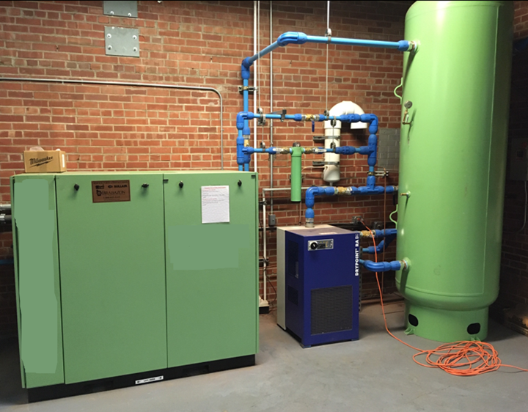

Tank reference drawing
